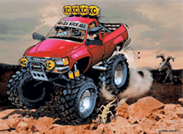

Wheeling Gear
- Food bag
- Toilet paper
- Paper towels
- Trash bags
- Batteries
- Medic kit
- Compass
- GPS
- Binoculars
- Trail guides
- Maps
- Wipes
- E rations
- Shovel/Ax
- Power tank
- Air hose
- Fire extinguisher
- Tow strap bag
- Tool bag
- Telephone
- Camp chairs
- Collection box
- Potty/Privy
- Flashlights
- Gloves

Camp Gear
- Tent
- Stove
- Sleeping pads
- Sleeping bags
- Dopp kit
- Utensils
- Cookware
- Plates/bowls
- Cups
- Lanterns

Clothing
- Shorts
- Shirts
- Pants
- Sox
- Underwear
- Shoes
- Hats
- Sunglasses
- Jackets

Dog stuff
- Food
- Treats
- Bowls
- Water bowl
- Collars
- Leashes